Experiment no:4 Date-19-4-2022

**AIM**

To familiarize with aggregate functions

1.List total loan

SELECT SUM(AMOUNT) FROM borrow;

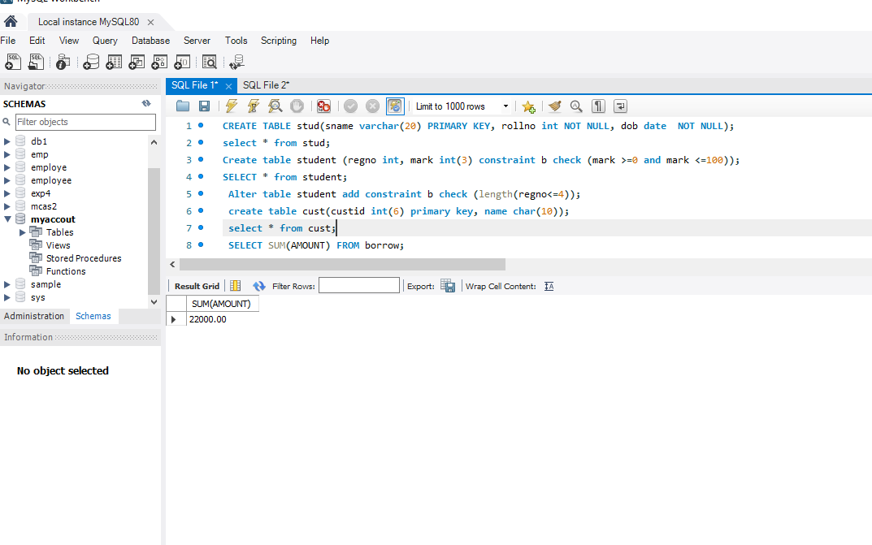

2.List total deposit

SELECT SUM(AMOUNT) FROM deposit;

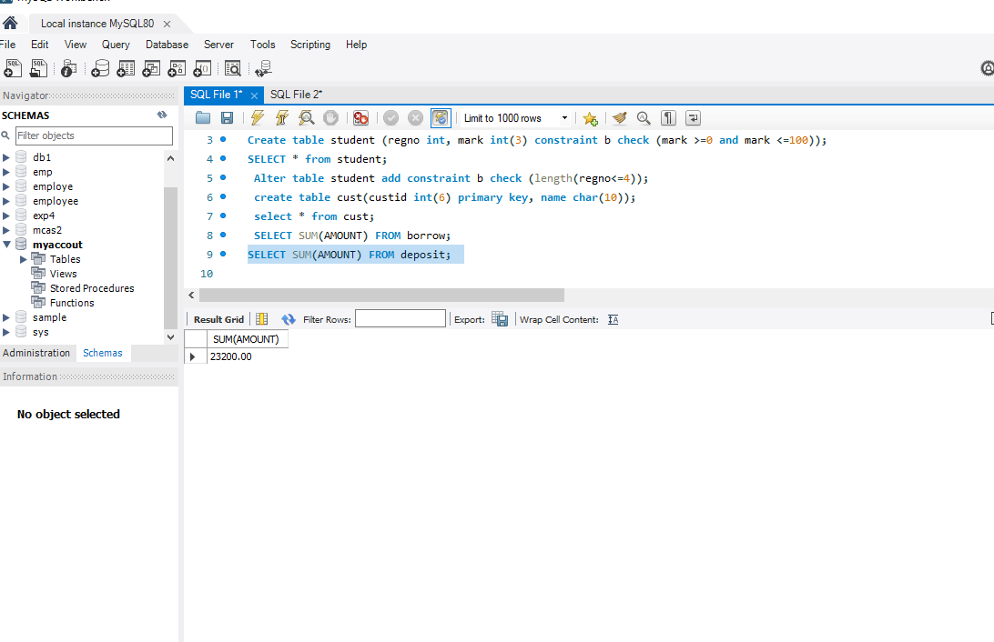

3.List total loan taken from KAROLBAGH branch

SELECT MAX(AMOUNT) FROM borrow WHERE Bname ='Karolbagh';

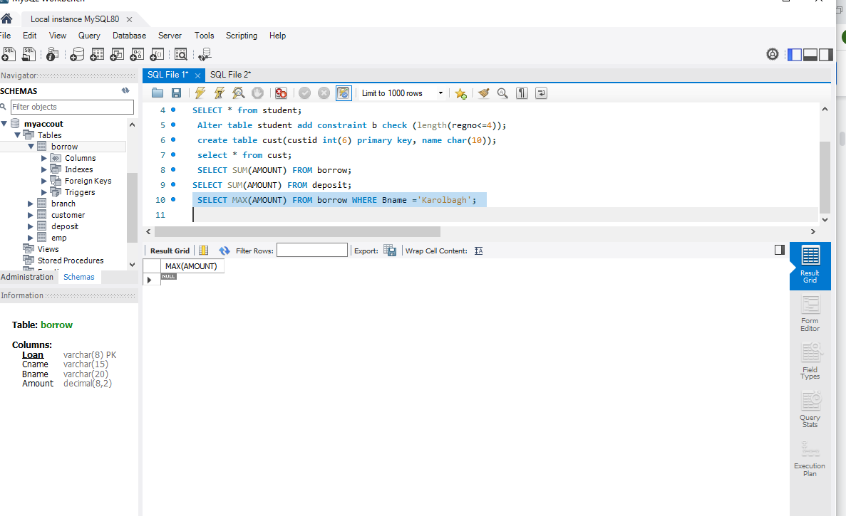

4.List total deposit of customers having account date later than 1-Jan-96

SELECT SUM(AMOUNT) from deposit where adate>'1995-03-01';

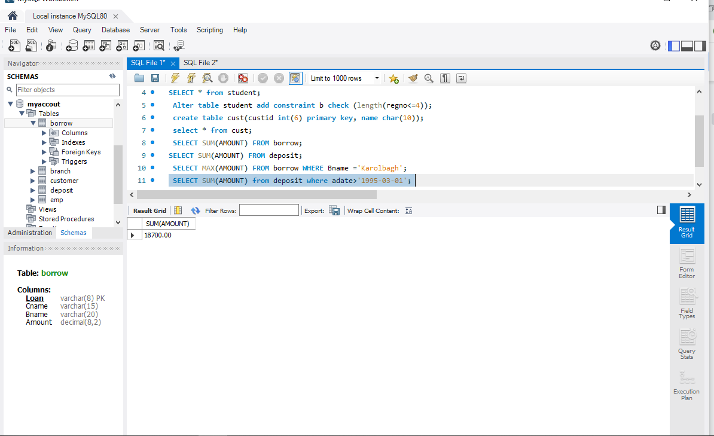

5.List total deposit of customers living in city NAGPUR

SELECT SUM(D1.AMOUNT) FROM DEPOSIT D1 , CUSTOMER C1 WHERE C1.CITY = 'NAGPUR' AND C1.CNAME = D1.CNAME;

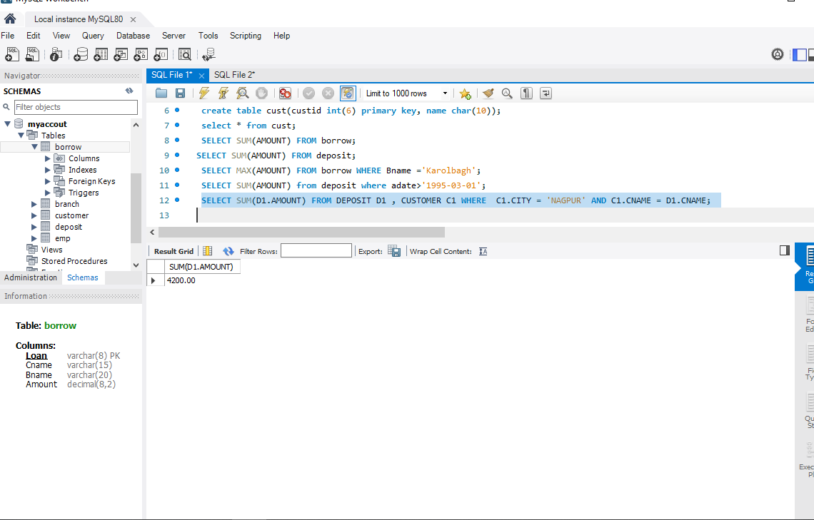

 6.List maximum deposit of customer living in Bombay

SELECT MAX(D1.AMOUNT) FROM DEPOSIT D1 , CUSTOMER C1 WHERE C1.CITY = 'Bombay' AND C1.CNAME = D1.CNAME;

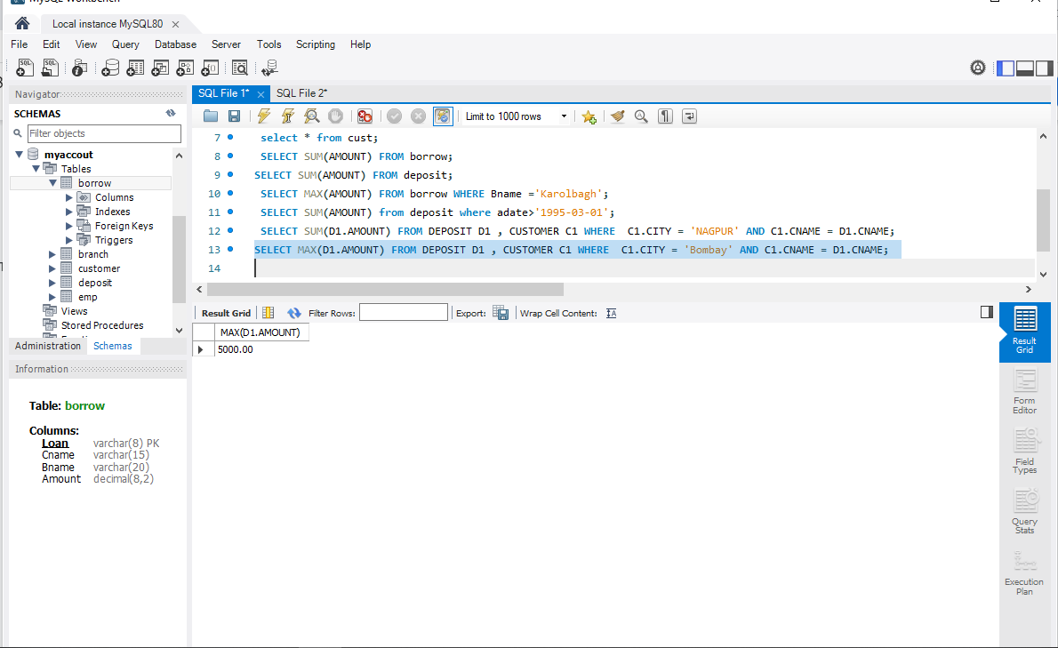

7.List total deposit of customer having branch in BOMBAY

SELECT SUM(AMOUNT) from deposit,BRANCH where city='BOMBAY';

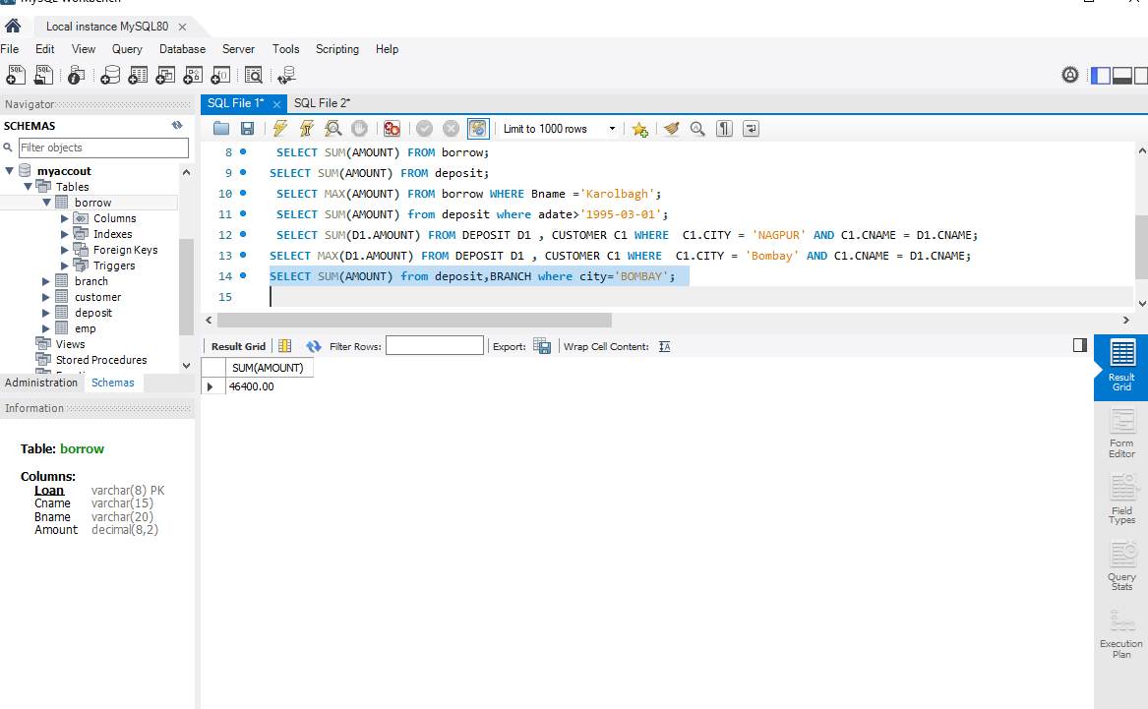

 8.Count total number of branch cities

SELECT COUNT(DISTINCT(CITY)) FROM BRANCH ;

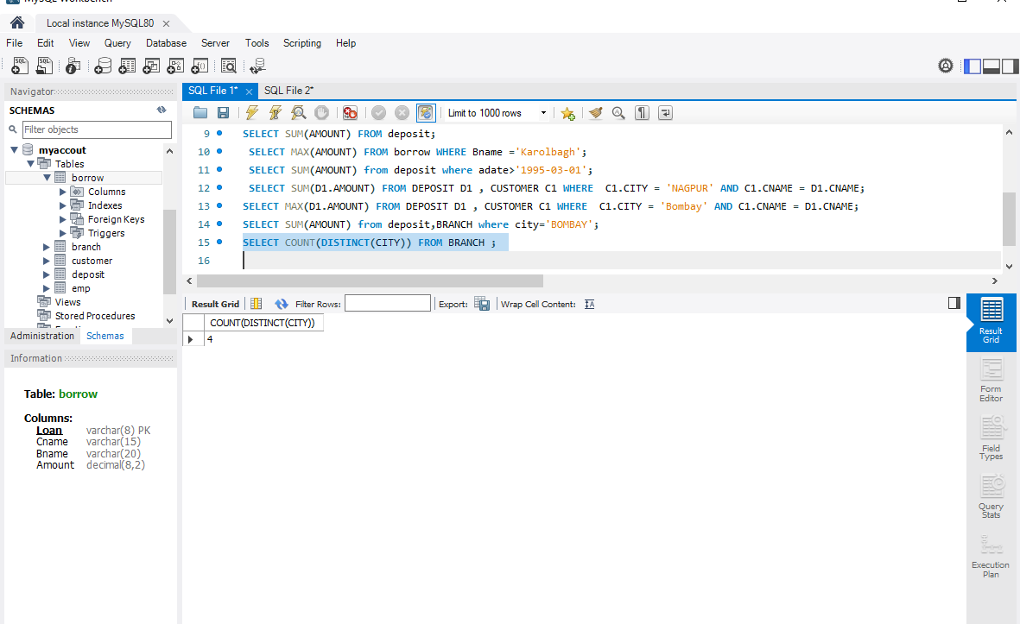

9.Count total number of customers cities

SELECT count(city) from CUSTOMER;

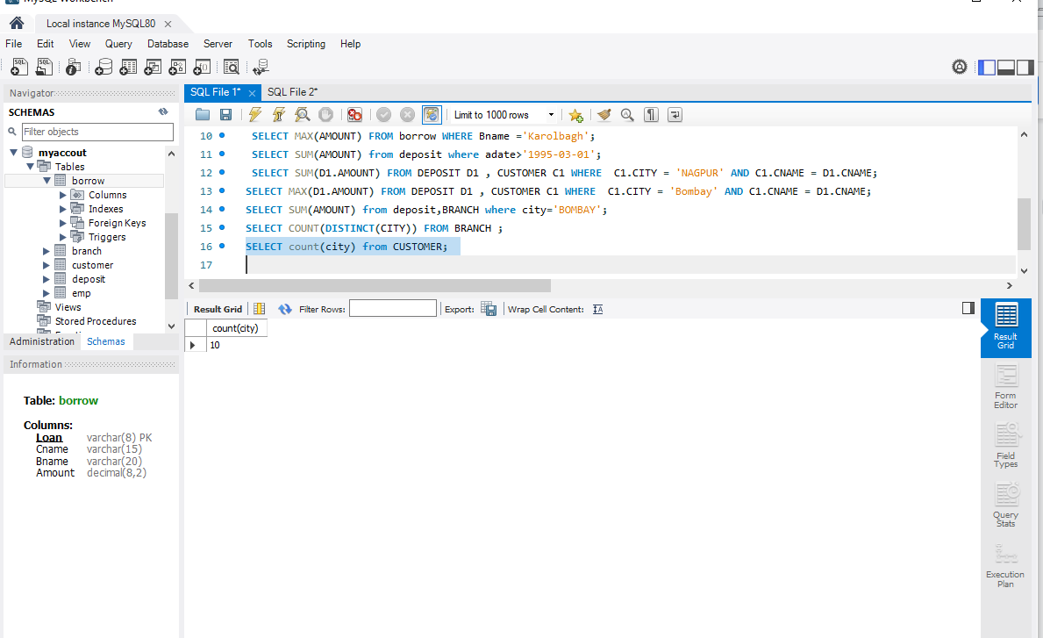

10.Give branch names and branch wise deposit

SELECT BNAME , SUM(AMOUNT) FROM DEPOSIT GROUP BY BNAME;

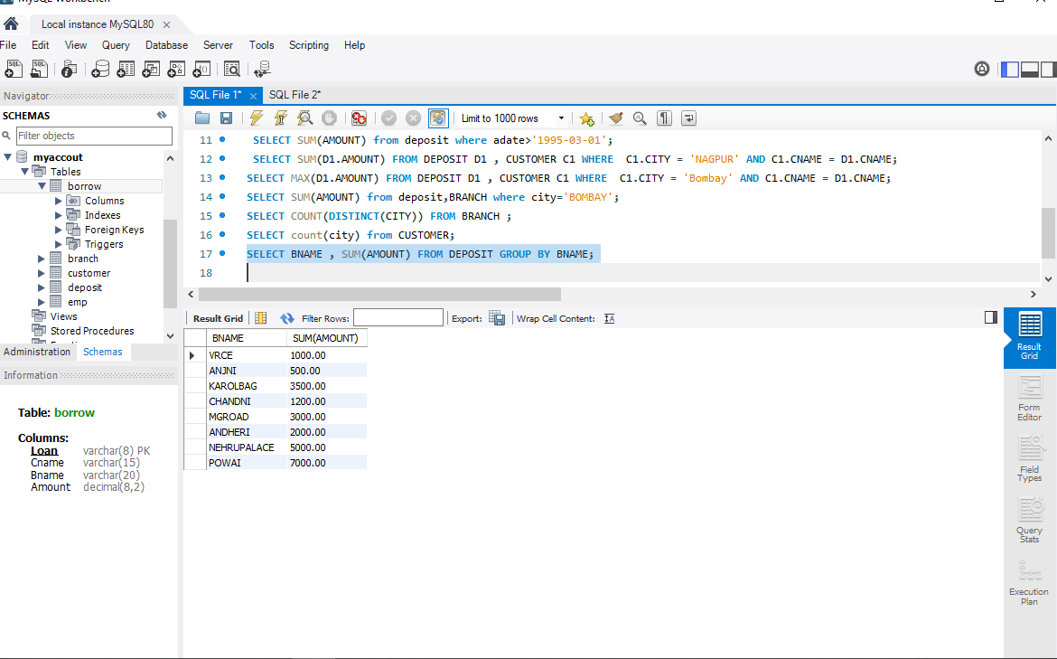

11.Give city wise name and branch wise deposit

SELECT C1.CITY , SUM(D1.AMOUNT) FROM CUSTOMER C1 , DEPOSIT D1 WHERE D1.CNAME = C1.CNAME GROUP BY C1.CITY;

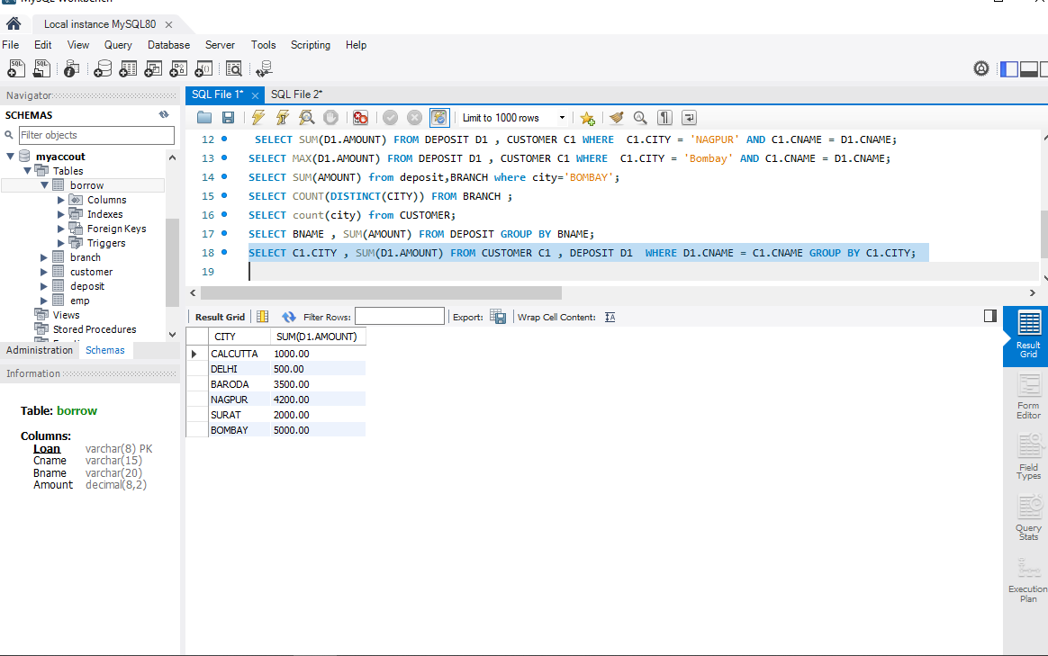

12.Give the branch wise loan of customer living in NAGPUR

SELECT BNAME , SUM(AMOUNT) FROM BORROW,CUSTOMER WHERE city ='NAGPUR' GROUP BY BNAME;

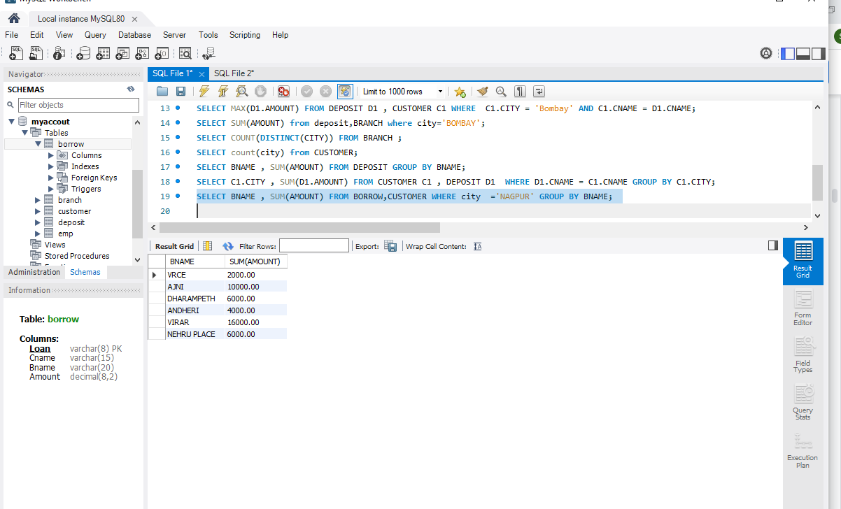

13.Count total number of customers

SELECT count(cname) from CUSTOMER;

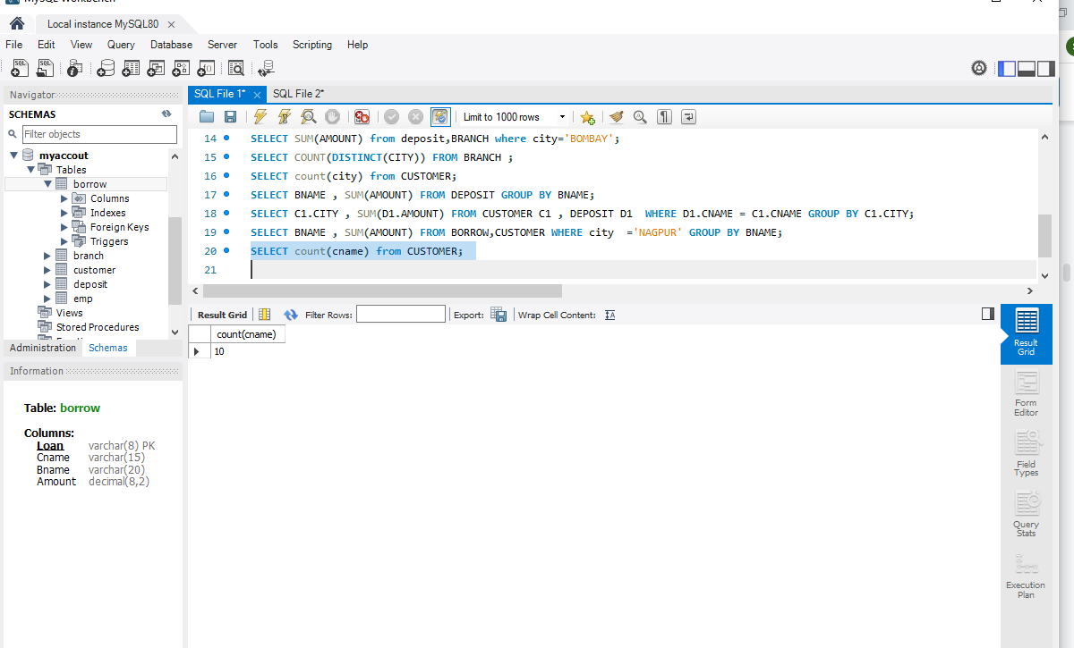

14.Count total number of depositors branch wise

select BName, count(*) from DEPOSIT, CUSTOMER where deposit.CNAME = CUSTOMER.CNAME group by BNAME;

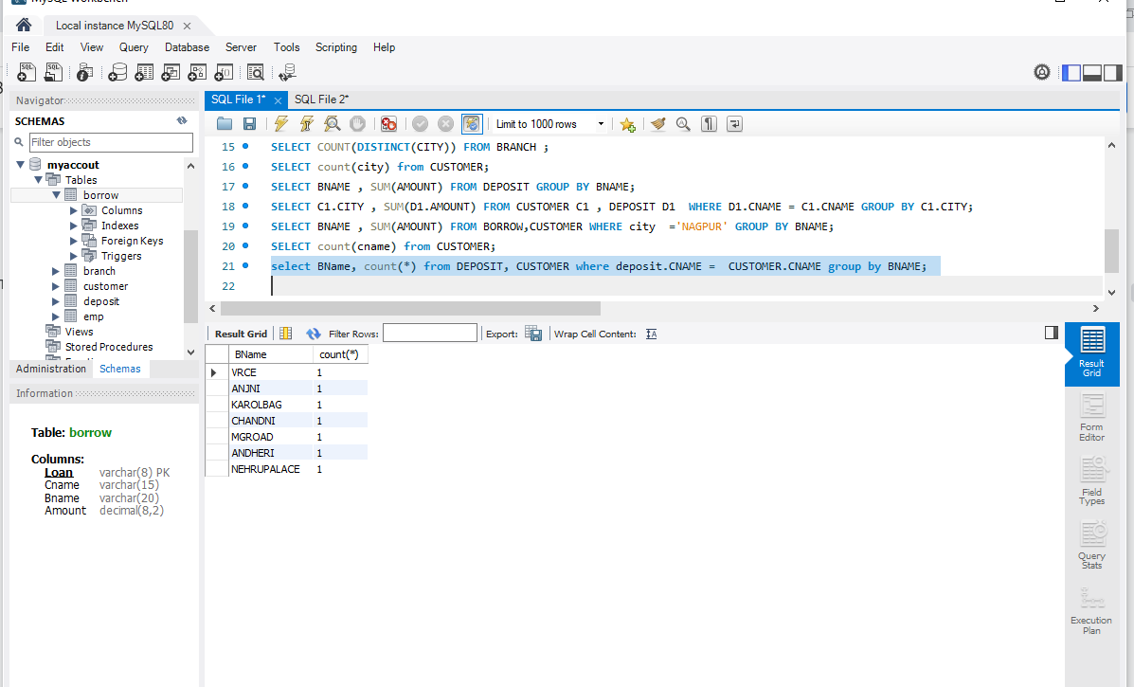

15.Count total number of depositors branch wise

16.Give maximum loan from branch VRCE

SELECT MAX(AMOUNT) FROM BORROW WHERE BNAME ='VRCE';

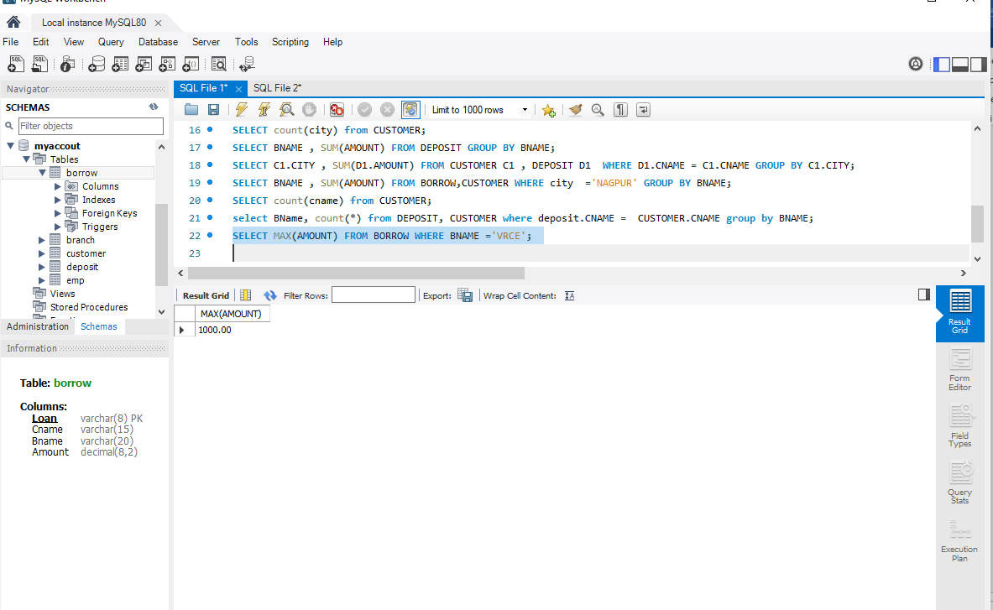

17.Give the number of customers who are depositors as well as borrowers

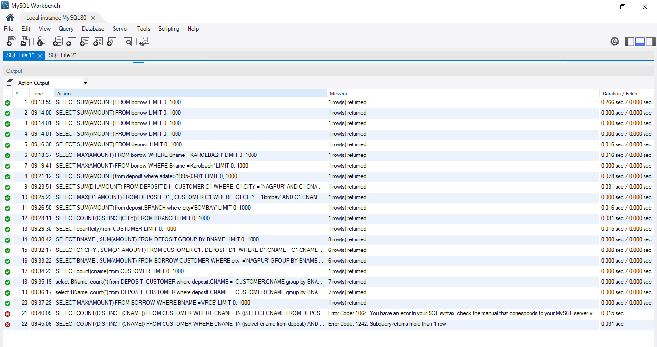

EXPERIMENT NO-5

**AIM**

To familiarize with set operations

**Questions**

1. List all the customers who are depositors but not borrowers.
2. List all the customers who are both depositors and borrowers

SELECT CNAME FROM DEPOSIT UNION (SELECT CNAME FROM BORROW);

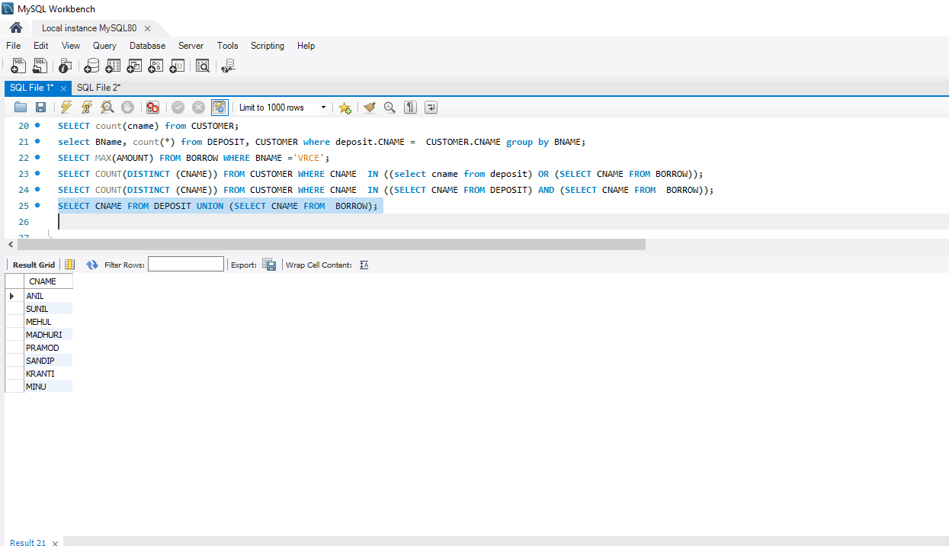

3. List all the depositors having deposit in all the branches where Sunil is having Account

SELECT D1.CNAME FROM DEPOSIT D1 WHERE D1.BNAME IN (SELECT D2.BNAME FROM DEPOSIT D2 WHERE D2.CNAME = 'SUNIL' );

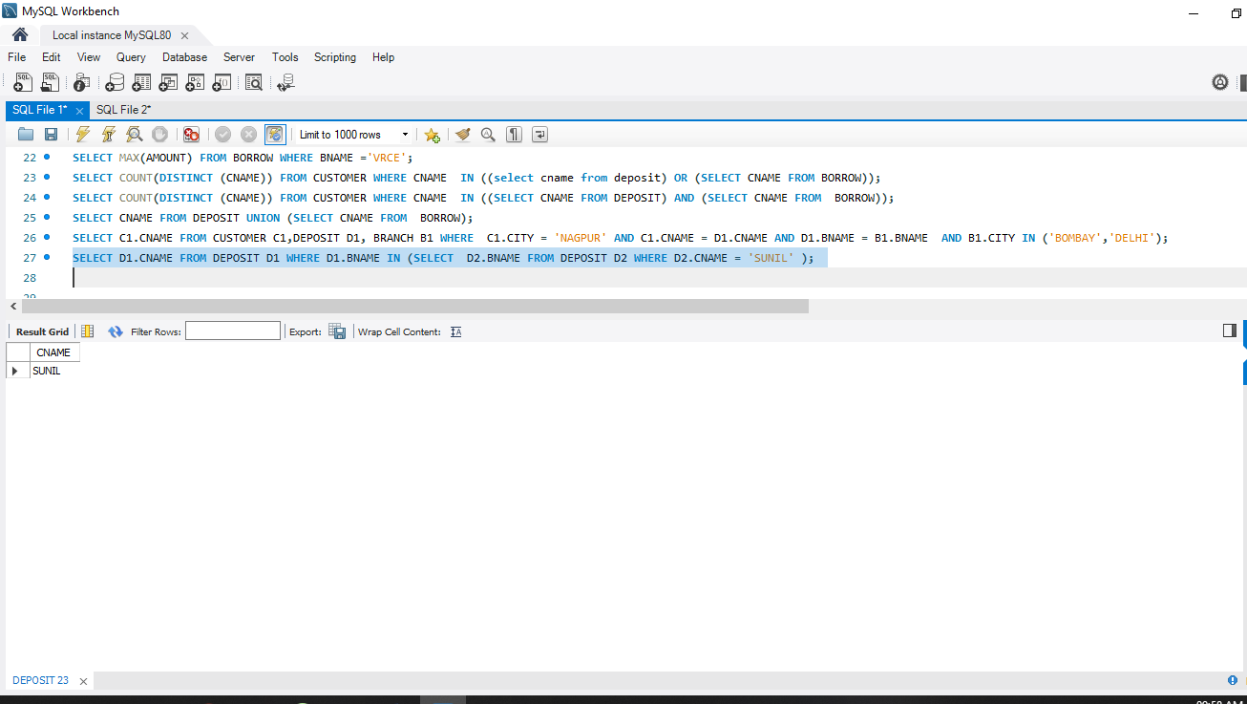

4. List all the customers living in city NAGPUR and having branch city BOMBAY or   DELHI

SELECT C1.CNAME FROM CUSTOMER C1,DEPOSIT D1, BRANCH B1 WHERE C1.CITY = 'NAGPUR' AND C1.CNAME = D1.CNAME AND D1.BNAME = B1.BNAME AND B1.CITY IN ('BOMBAY','DELHI');

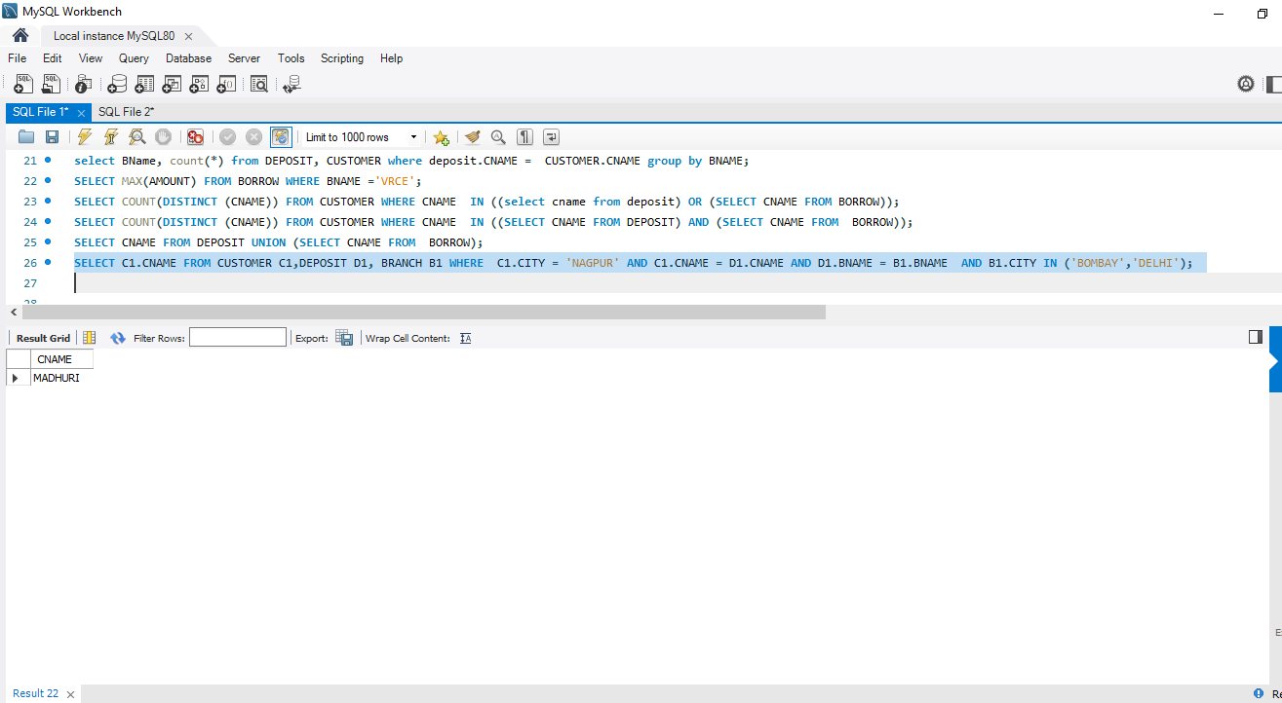

5. List all the depositors living in city NAGPUR

SELECT Distinct(CUSTOMER.CNAME) from CUSTOMER,DEPOSIT WHERE City='NAGPUR';

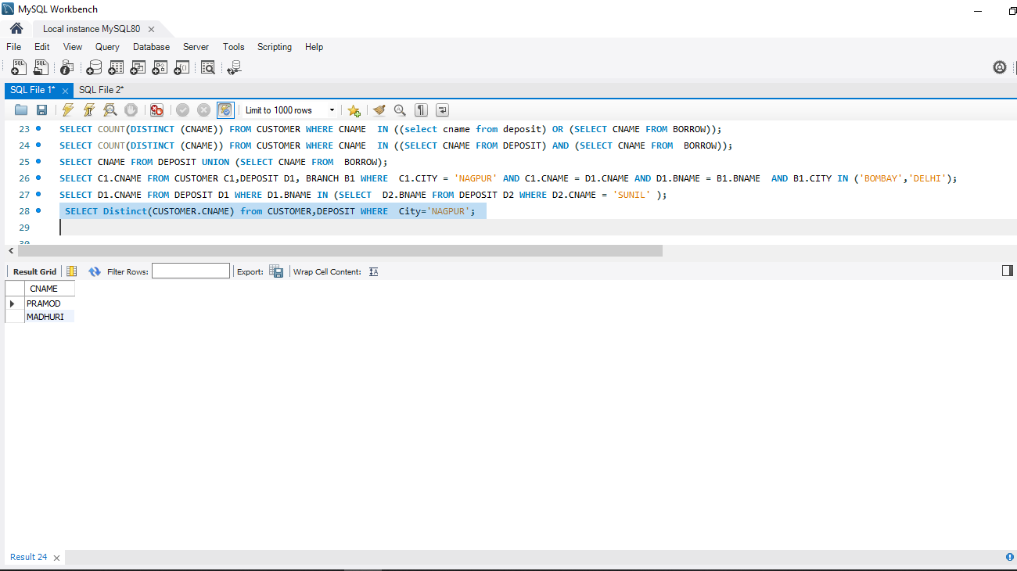

6. List all the depositors living in the city NAGPUR and having branch in city BOMBAY

SELECT C1.CNAME FROM CUSTOMER C1,DEPOSIT D1, BRANCH B1 WHERE C1.CITY = 'NAGPUR' AND C1.CNAME = D1.CNAME AND D1.BNAME = B1.BNAME AND B1.CITY IN ('BOMBAY');

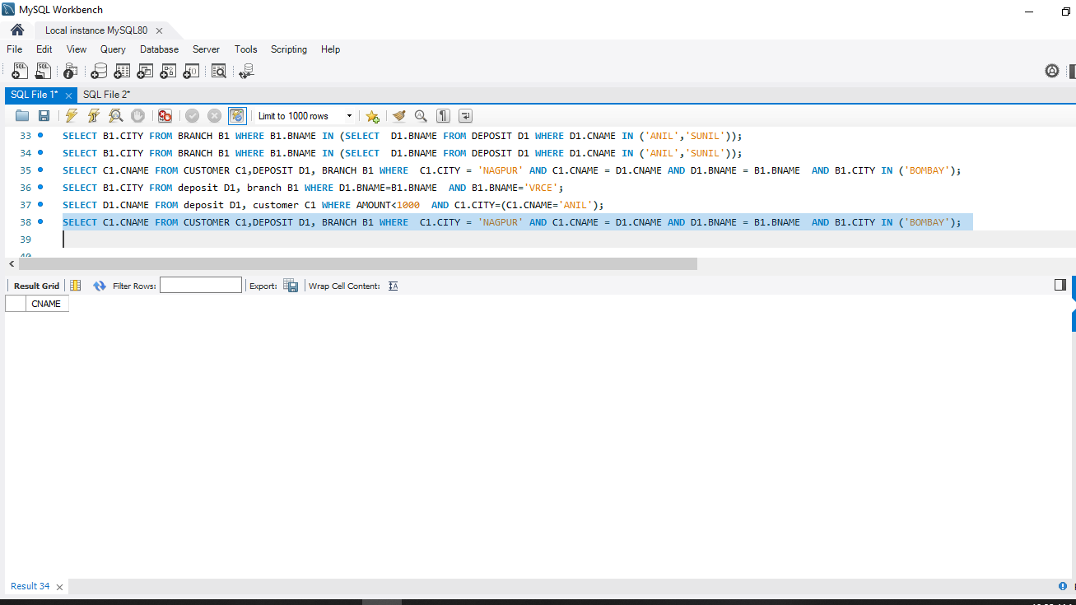

7. List the branch cities of Anil and Sunil

SELECT B1.CITY FROM DEPOSIT D1, BRANCH B1 WHERE D1.BNAME = B1.BNAME AND D1.CNAME IN ('SUNIL' ,'ANIL');

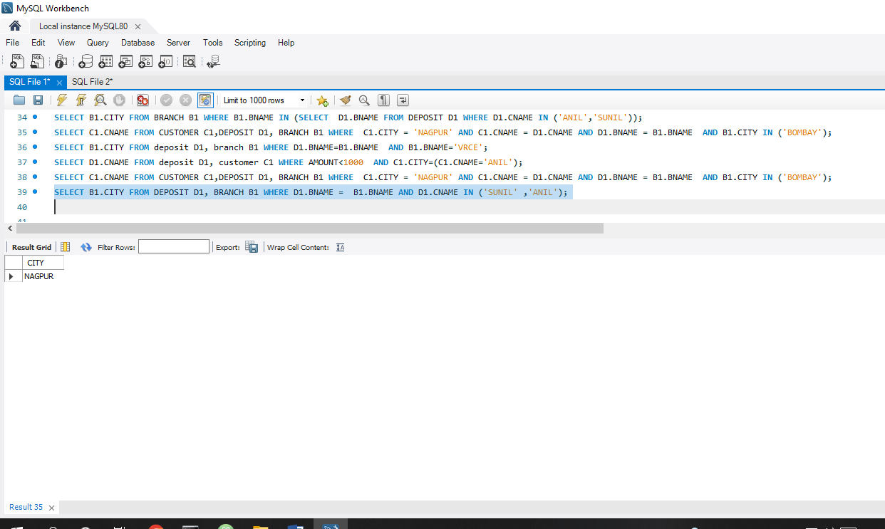

8. List the customers having deposit greater than 1000 and loan less than 10000.

SELECT DISTINCT D1.CNAME FROM deposit D1, borrow B1 WHERE D1.AMOUNT>1000 AND B1.AMOUNT<10000;

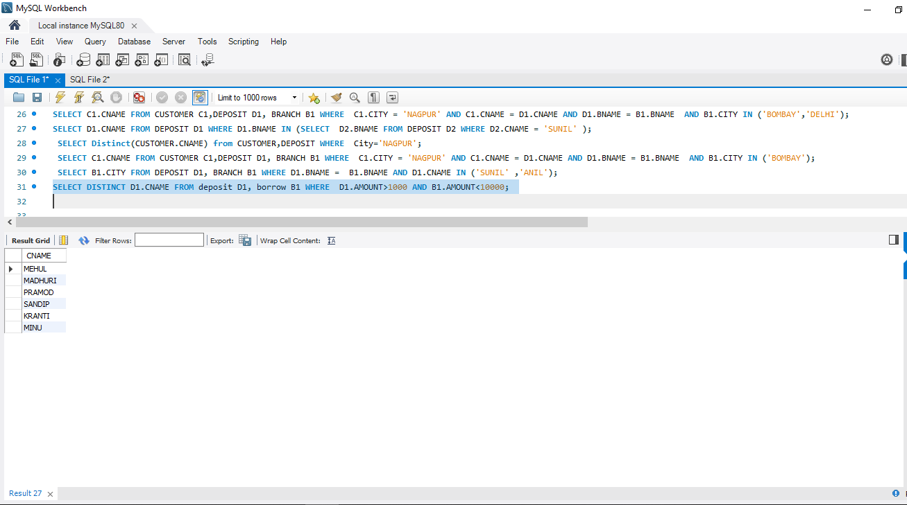

9. List the cities of depositors having branch VRCE.

SELECT B1.CITY FROM deposit D1, branch B1 WHERE D1.BNAME=B1.BNAME AND B1.BNAME='VRCE';

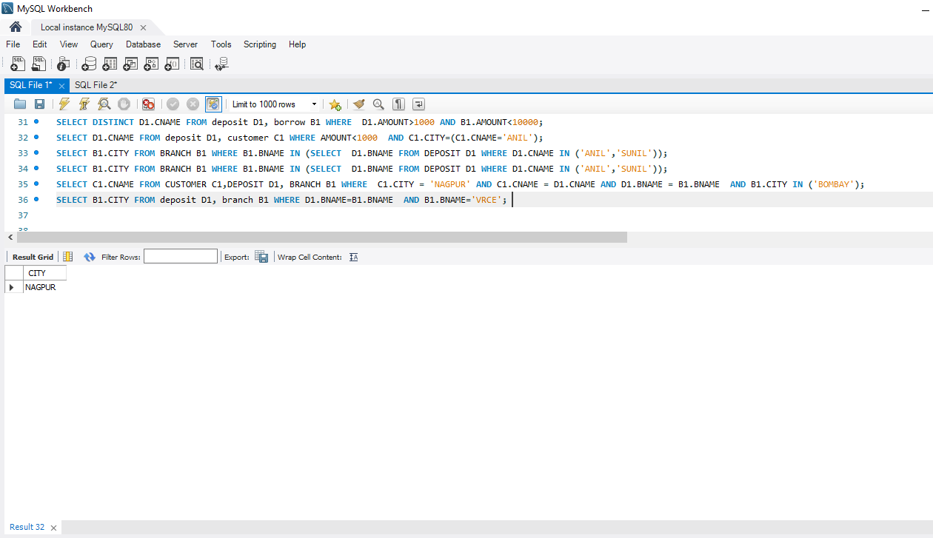

10. List the depositors having amount less than 1000 and living in the same city as Anil

SELECT D1.CNAME FROM deposit D1, customer C1 WHERE AMOUNT<1000 AND C1.CITY=(C1.CNAME='ANIL');

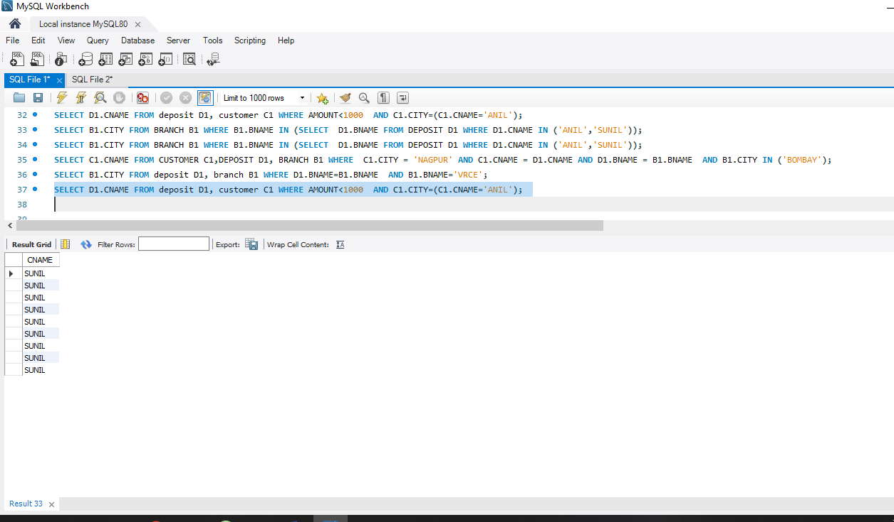

11. List all the cities where branches of Anil and Sunil are locate

SELECT B1.CITY FROM BRANCH B1 WHERE B1.BNAME IN (SELECT D1.BNAME FROM DEPOSIT D1 WHERE D1.CNAME IN ('ANIL','SUNIL'));

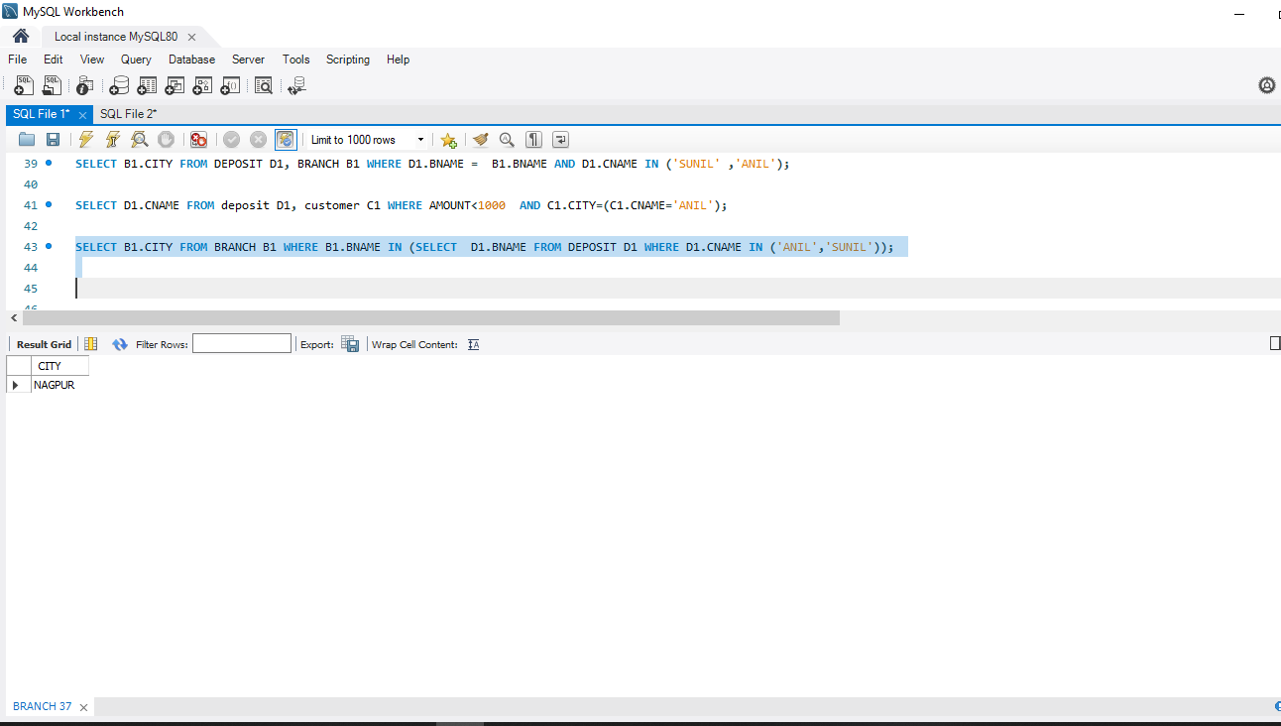

12. List the amount for the depositors living in the city where Anil is living

SELECT DISTINCT(D1.CNAME),D1.AMOUNT ,C1.CITY FROM deposit D1,  CUSTOMER C1, BRANCH B1 WHERE D1.CNAME=C1.CNAME AND C1.CITY  IN(SELECT C2.CITY FROM customer C2 WHERE C2.CNAME='ANIL');

